WEBSITE URL:[GEOFABRIK // Home](https://www.geofabrik.de/)

STEP1

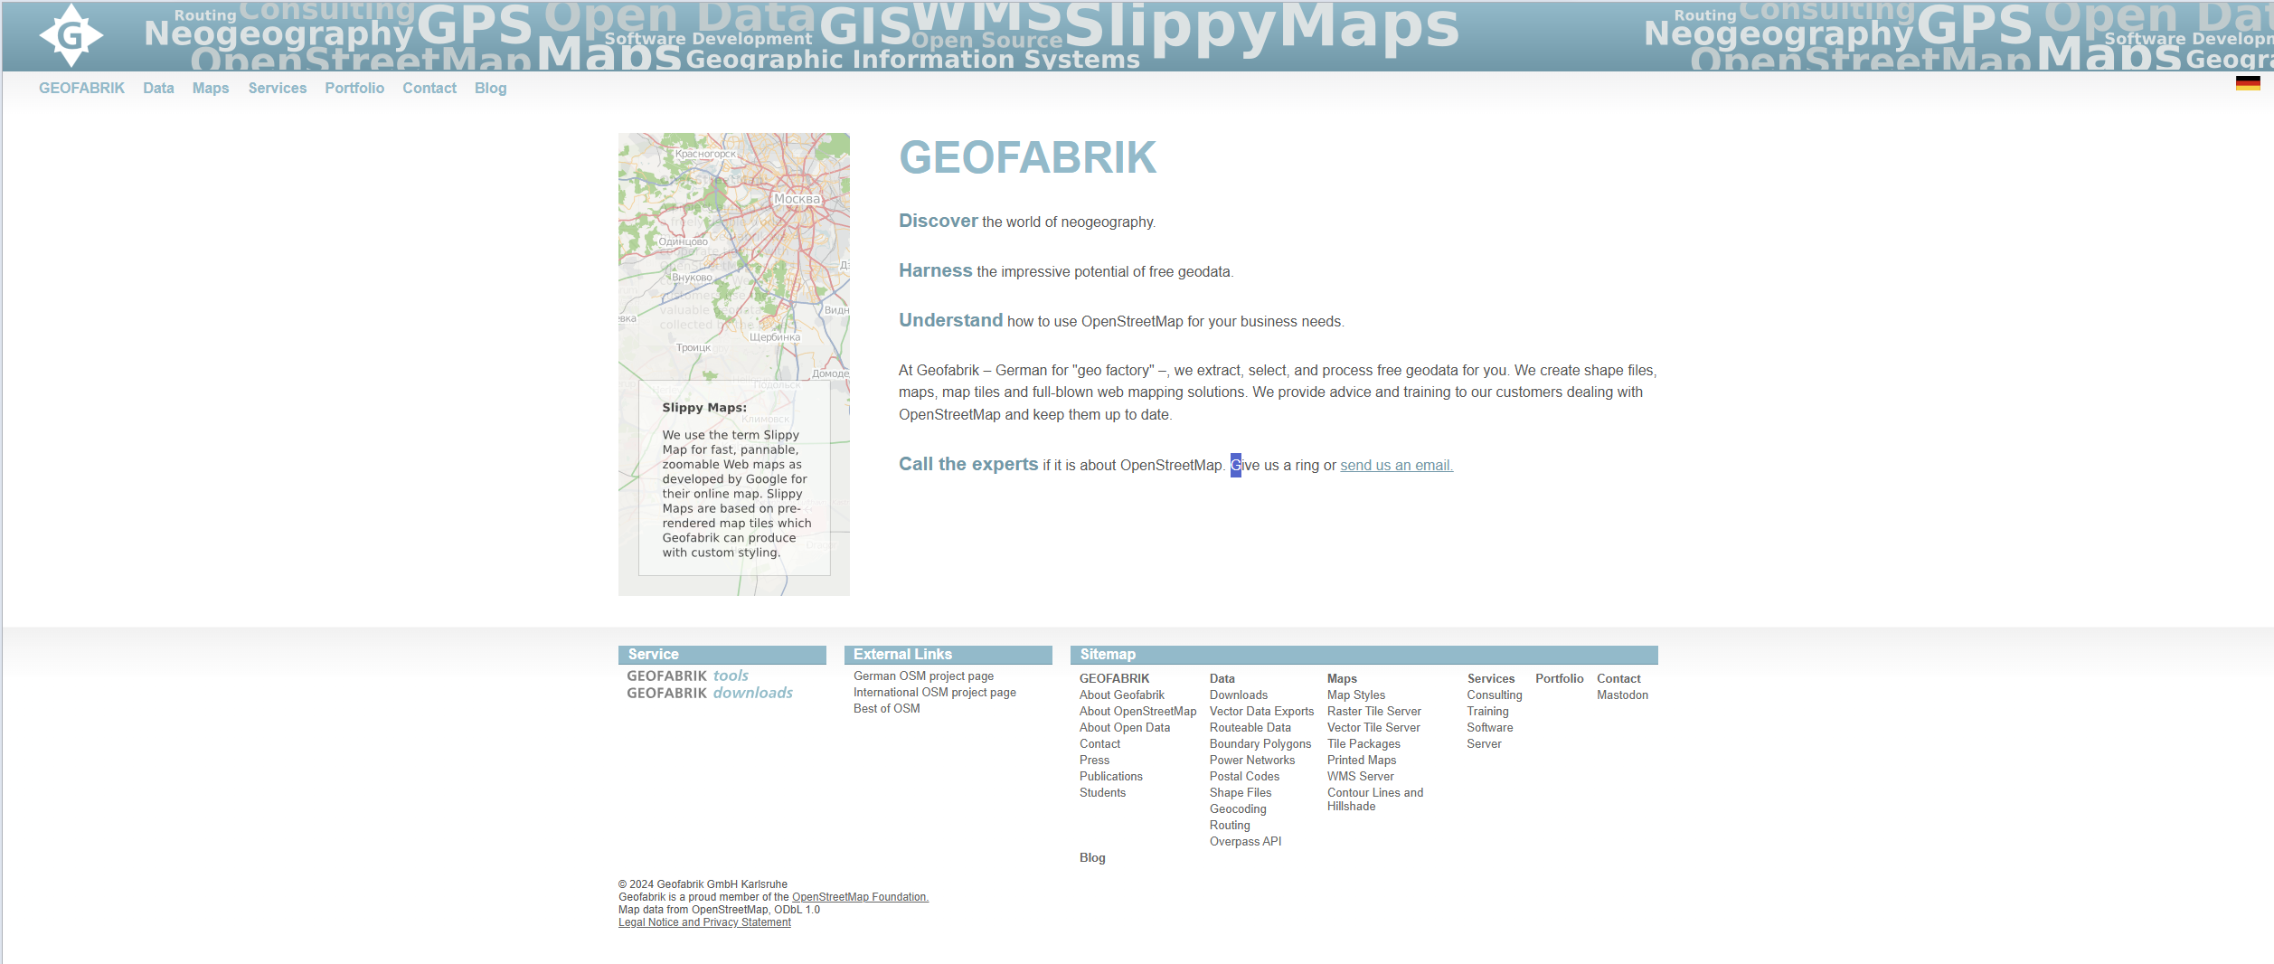

STEP2

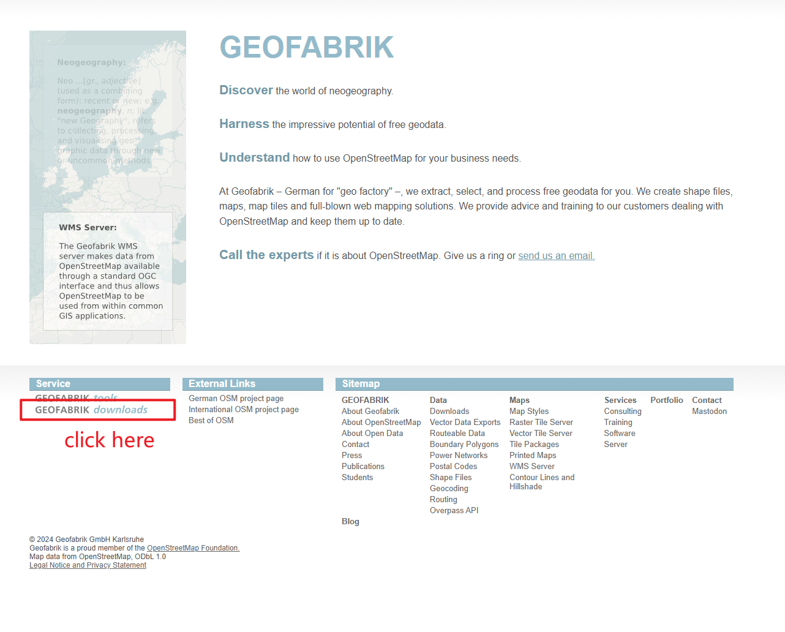

STEP3

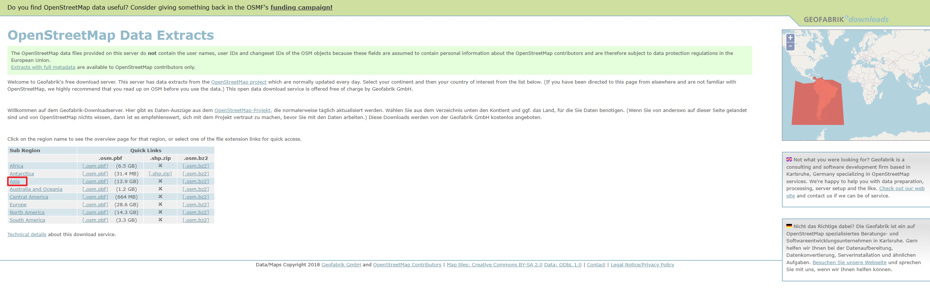

STEP4

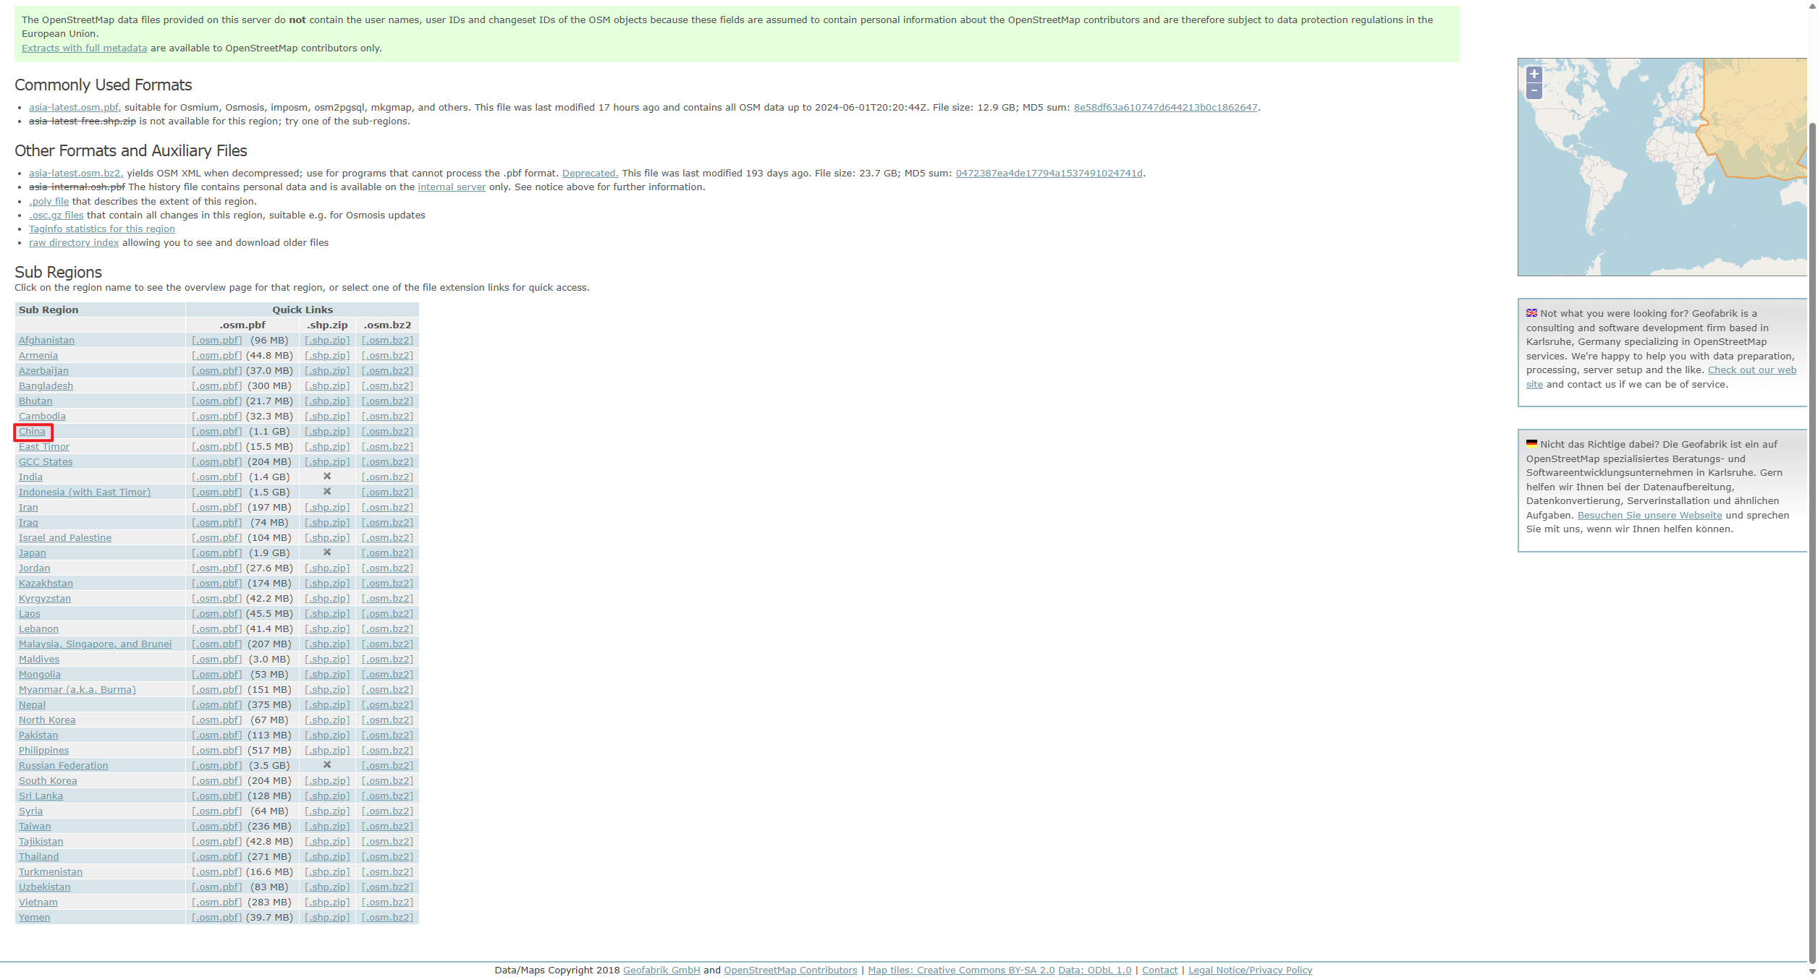

STEP5

